Git hub command line

1.git –version

2.git –config list

It will show the global setting of git

3.to change the user name

Git config –global user.name “MenhiBaba”

4.To change the email id

Git –global usre.email [vickykumarj7@gmail.com](mailto:vickykumarj7@gmail.com)

5.To get help on action

Git help config or git config –help

It will show more option available with git

6.git add --help

To add file content to index

To initialize the code from existing code

1.To check the repository

$ ls

2. To track who chaged the code with date and time

$ ls –la

3.To initialize the local repository

$ git init

And to check the initialized local file as repository

$ ls –la

This .git structure of git’s repository plays an importanty role to track the prioject.

If .git getting removed we can’t track the application

$ rm –rf .git

$ ls –la

To make the folder as repository again

$ git init

So till now we did not commit anything

Before first commit

--to check the commit status

$ Git status

Just we want to don’t show the unrelated file of repository to anyone, we use the following command.

$ touch .gitignore

More on more

1.Working area –where we are working. All file will be available

2.staging area---only those file will be available which are going to commit.

Sub set of working area

3. Git hub directory area

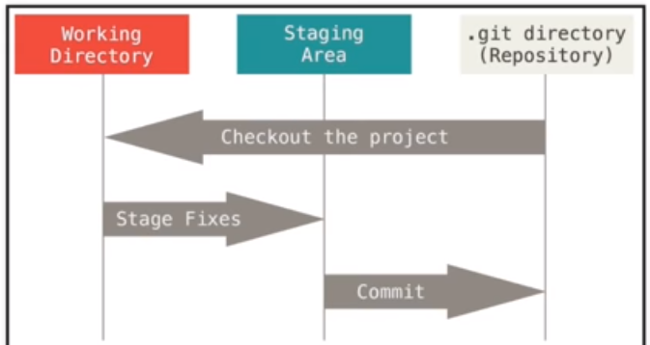

To add the untracked file to staging area to move it to the .git repository

$ git add –A

To pull all files to staging area

$ git add <File_Name>

To pull specific file to staging area

Check the status with which ,which files are going to commit from staging area

$ git status

To reset the file from staging area to working directory

To commit the changes

$ git commit –m “initial commit”

$ git status

Now to to check the hash code of commited code/file which tells about author who committed ,date ,comment and all

$ git log

Now clone the project from remore repository

$ git clone <url> <where to clone>

. show the current local directory

$cd.. to go absolute path

And change the file where do you want to keep remote cloned project

And write the above command if you don’t have the authorization just create the authentication given in attached document

Generate_rsh.doc